# Spinifex function dependencies (for Spinifex rebase)

## Via `funGraph` Jackson’s package on GitHub

## As of 18/05/2020, commit: df72e9

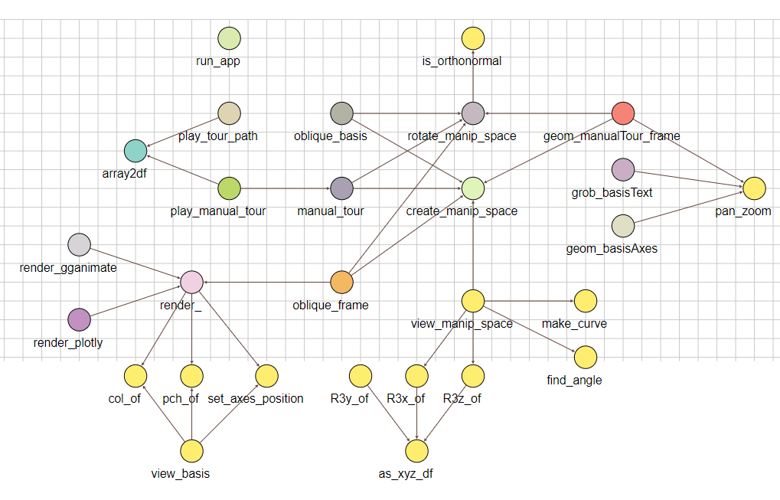

# Spinifex rebase notes

## As of 18/05/2020, commit: df72e9



New shiny apps!

-“intro”

-“primary”

Attention/cleanup:

Attention/cleanup:

Deprecated:

New-

to ggproto_ (some as _Grob?)